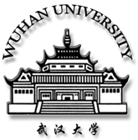

在读证明
Certification

兹证明 ，男/女，学号 ， 年 月 日出生，自 年 月起在武汉大学 学院学习 专业。如果通过所有课程的考试、答辩合格，将于 年 月 获得 博/硕 士学位。

This is to certify that, Mr. / Ms. ,student ID No. , born on , has been studying in the School of , Wuhan University and specializing in since . Master/Doctor’s Degree will be awarded in if the curriculum required is completed with satisfactory grades and the dissertation is successfully composed.
武汉大学Wuhan University
日期 Date:

